HTML:
<html><head>
<title>Movie Ticket</title><style>
body {background-color: lightblue;font-family: Arial, sans-serif;margin: 0;padding: 20px;}
h1 {text-align: center;margin-bottom: 20px;}
.image {text-align: center;margin-bottom: 25px;}
.image img {display: block;margin: auto;}
table {width: 50%;margin: auto;border-collapse: collapse;text-align: center;background-color: white;}
th, td {padding: 10px;}
caption {font-weight: bold;margin-bottom: 8px;}
h2 {width: 50%;margin: 25px auto 10px;}
ul, ol {width: 45%;margin: 8px auto;line-height: 1.4;}
form {width: 50%;margin: auto;background-color: white;padding: 20px;box-sizing: border-box;border-radius: 8px;box-shadow:0 4px 8px rgba(0,0,0,0.1);}
form p {margin-bottom: 8px;}
input, select {width: 100%;padding: 8px;box-sizing: border-box;margin-top: 5px;}
button {display: block;margin: 20px auto 0;padding: 10px 25px;cursor: pointer;background-color: #0073e6;color: white;border: none;border-radius: 5px;}
button:hover {background-color: #005bb5;}</style></head>
<body><h1>Pick your movie and confirm your tickets</h1>
<div class="image"> <img src="mov.jpg" alt="Movie Poster"></div>
<table border="1"> <caption>Movie ticket booking status</caption>
<tr><th>Movie name</th><th>Available seats</th></tr>
<tr><td>Vishwanath&sons</td><td>120 seats</td></tr>
<tr><td>Sita Ramam</td><td>90 seats</td></tr>
<tr><td>Hi nana</td><td>50 seats</td></tr></table>
<h2>Show details</h2>
<ul><li><b>Cinema Hall:</b> ZEON Cinemas</li><li><b>Date:</b> 05th October</li>
<li><b>Ticket fare:</b> ₹500</li></ul>
<ol><li>Entry & Registration (10:00 AM)</li><li>Online Reservation available</li><li>Total Three Movies</li>
<li>Snacks & Refreshments (1:00 PM)</li></ol>
<h2><i>Movie ticket reservation</i></h2><form action="ticket" method="post">
<p><label>Ticket ID</label><br><input type="number" name="ticketid" required></p>
<p> <label>Full name</label><br><input type="text" name="fullname" required></p>
<p><label>Email</label><br><input type="email" name="email" required></p>
<p><label>Select movie</label><br>
<select name="movie"><option value="Vishwanath&sons">Vishwanath&sons</option>
<option value="Sita Ramam">Sita Ramam</option><option value="Hi nana">Hi nana</option></select></p>
<p><label>Show time:</label><br>
<select name="time"><option value="9:30">Morning (9:30)</option>
<option value="1:30">Afternoon (1:30)</option><option value="5:30">Evening (5:30)</option></select></p>
<button type="submit">Book Now</button></form></body></html>

SERVLET:
import java.io.*;
import javax.servlet.*;
import javax.servlet.http.*;
import javax.servlet.annotation.WebServlet;
import java.sql.*;

@WebServlet("/ticket")
public class ticket extends HttpServlet {
private static final long serialVersionUID = 1L;
private static final String DB_URL =
"jdbc:mysql://localhost:3306/servlet?useSSL=false&allowPublicKeyRetrieval=true&serverTimezone=UTC";
private static final String DB_USER = "root"; private static final String DB_PASS = "mysql";
protected void doPost(HttpServletRequest request,HttpServletResponse response)
throws ServletException, IOException {
response.setContentType("text/html");
PrintWriter out = response.getWriter();
int ticketid =Integer.parseInt(request.getParameter("ticketid"));
String fullname =request.getParameter("fullname");
String email =request.getParameter("email");
String movie =request.getParameter("movie");
String time =request.getParameter("time");
try {
Class.forName("com.mysql.cj.jdbc.Driver");
Connection conn =DriverManager.getConnection(DB_URL, DB_USER, DB_PASS);
String insertSQL ="INSERT INTO ticket(ticketid, fullname, email, movie, time) " +"VALUES (?, ?, ?, ?, ?)";
PreparedStatement ps =conn.prepareStatement(insertSQL);
ps.setInt(1, ticketid);
ps.setString(2, fullname);
ps.setString(3, email);
ps.setString(4, movie);
ps.setString(5, time);
ps.executeUpdate();
ps.close();
out.println("<!DOCTYPE html>");
out.println("<html>"); out.println("<head>");
out.println("<title>Booking Successful</title>");
out.println("<style>"); out.println("body {");
out.println("background-color:#f4f9e9;"); out.println("font-family:Arial;");
out.println("padding:30px;"); out.println("}");
out.println(".success {");
out.println("width:50%;"); out.println("margin:auto;");
out.println("background-color:#d4edda;"); out.println("padding:20px;");
out.println("text-align:center;"); out.println("border-radius:8px;"); out.println("}");
out.println("h1,h2 {"); out.println("color:#08783f;"); out.println("text-align:center;"); out.println("}");
out.println("table {"); out.println("width:50%;"); out.println("margin:20px auto;");
out.println("border-collapse:collapse;"); out.println("background-color:white;"); out.println("}");
out.println("th {"); out.println("background-color:#08783f;");
out.println("color:white;"); out.println("padding:10px;"); out.println("}");
out.println("td {"); out.println("border:1px solid #aaa;"); out.println("padding:10px;");
out.println("text-align:center;"); out.println("}");
out.println("</style>"); out.println("</head>"); out.println("<body>");
out.println("<div class='success'>"); out.println("<h1>Booking Successful!</h1>");
out.println("<p>Thank you, " + fullname + "!</p>");
out.println("<p>Your movie ticket has been booked successfully.</p>");
out.println("</div>"); out.println("<h2>Your Booking Details</h2>"); out.println("<table>");
out.println("<tr>"); out.println("<th>Ticket ID</th>"); out.println("<th>Full Name</th>");
out.println("<th>Email</th>"); out.println("<th>Movie</th>"); out.println("<th>Show Time</th>");
out.println("</tr>"); out.println("<tr>"); out.println("<td>" + ticketid + "</td>");
out.println("<td>" + fullname + "</td>"); out.println("<td>" + email + "</td>");
out.println("<td>" + movie + "</td>"); out.println("<td>" + time + "</td>"); out.println("</tr>");
out.println("</table>");
String selectSQL ="SELECT ticketid, fullname, email, movie, time " + "FROM ticket ORDER BY ticketid DESC";
PreparedStatement selectPS =conn.prepareStatement(selectSQL);
ResultSet rs = selectPS.executeQuery();
out.println("<h2>All Movie Ticket Reservations</h2>"); out.println("<table>");
out.println("<tr>"); out.println("<th>Ticket ID</th>"); out.println("<th>Full Name</th>");
out.println("<th>Email</th>"); out.println("<th>Movie</th>"); out.println("<th>Show Time</th>");
out.println("</tr>");
while (rs.next()) {
out.println("<tr>");
out.println("<td>" + rs.getInt("ticketid") + "</td>");
out.println("<td>" + rs.getString("fullname") + "</td>");
out.println("<td>" + rs.getString("email") + "</td>");
out.println("<td>" + rs.getString("movie") + "</td>");
out.println("<td>" + rs.getString("time") + "</td>"); out.println("</tr>"); }
out.println("</table>");
rs.close(); selectPS.close();
conn.close(); out.println("</body>"); out.println("</html>");
} catch (Exception e) {
out.println("<h2>Booking Failed</h2>"); out.println("<p>" + e.getMessage() + "</p>");
e.printStackTrace(out);}}}

output:
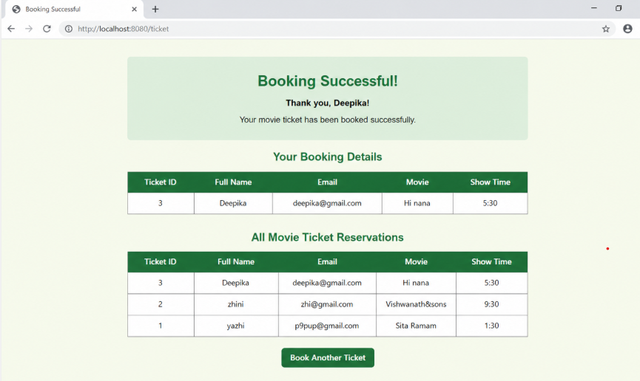

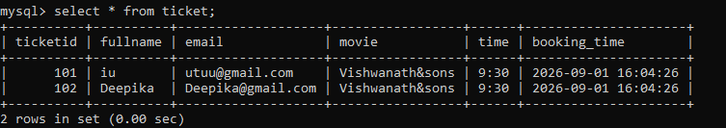

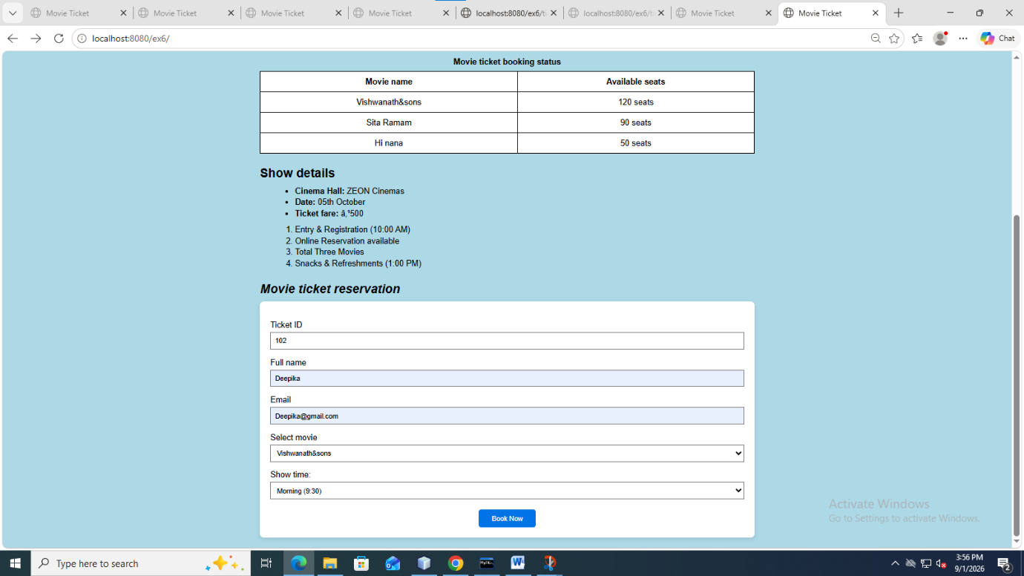

OUTPUT:

